Experiment 5
Name: Padma Priya D Roll No: 240701377
Conduct task analysis for an application and document user flows. Create corresponding wireframes using Lucidchart.

OBJECTIVE
- To understand user interaction with the app
- To design clear user flow
- To create wireframes (low-fidelity prototypes)
- To improve usability and navigation

TOOLS USED
- Lucidchart (Wireframing & Flow Diagram Tool)
THEORY
Task analysis is the process of identifying how a user interacts with an application to complete a task.
User flow represents the step-by-step journey of a user inside the application.

Wireframes are low-fidelity designs used to visualize layout and structure before development.
APP NAME

StudyMate – Assignment Management App
TASK ANALYSIS

Main Tasks Identified:
- Open the application
- Login using email and password
- View assignments
- Add new assignment
- Check assignment status
- View profile
- Logout

USER FLOW DESCRIPTION
The flow of the application is as follows:
- User opens the app (Splash Screen)
- User navigates to Login Screen
- User enters login credentials
- System checks login validity
  - If incorrect → shows error
  - If correct → goes to Dashboard
- User views assignments
- User can add a new assignment
- Assignment is added successfully
- User navigates to Profile screen
- User can logout
- Application ends
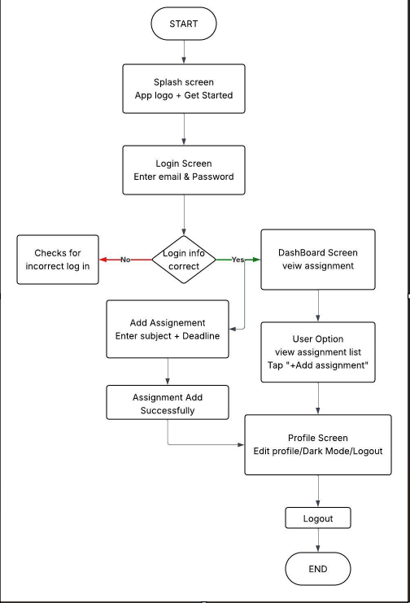
FLOW DIAGRAM

WIREFRAME DESIGN (LOW-FIDELITY)
The following wireframes were designed:

1. Splash Screen
- App logo
- App name (StudyMate)
- Get Started button

2. Login Screen
- Email input
- Password input
- Login button

3. Dashboard Screen
- Assignment list
- Status (Pending/Completed)
- Add Assignment option

4. Add Assignment Screen
- Subject input
- Deadline input
- Submit button

5. Profile Screen
- User details
- Edit profile option
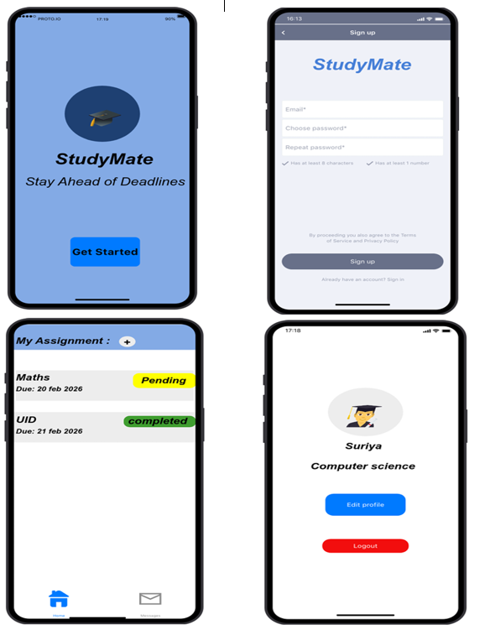
- Logout button

